**Evaluation of performance and emission characteristics of cashew nutshell liquid with aluminum oxide (Al2O3)**

##### A PROJECT REPORT

###### ***Submitted by***

**Richard T RA1911002020010**

**A Deva Vishal RA1911002020035**

**D Venkata Satvik RA1911002020048**

**Darji Dattu RA1911002020096**

***in partial fulfillment for the award of the degree***

***of***

##### BTECH

IN

MECHANICAL ENGINEERING



SRM INSTITUTE OF SCIENCE AND TECHNOLOGY

RAMAPURAM

MAY & 2023

**SPECIMEN**

SOME PERFORMANCE ASPECTS CONSIDERATIONS OF A CLASS OF ARTIFICIAL NEURAL NETWORK

##### A PROJECT REPORT

###### ***Submitted by***

**Richard T RA1911002020010**

**A Deva Vishal RA1911002020035**

**D Venkata Satvik RA1911002020048**

**Darji Dattu RA1911002020096**

***in partial fulfillment for the award of the degree***

***of***

**B.Tech. (FULL TIME)**

*in*

# **MECHANICAL ENGINEERING**



SRM INSTITUTE OF SCIENCE AND TECHNOLOGY

RAMAPURAM

##### MAY 2023

SRM INSTITUTE OF SCIENCE AND TECHNOLOGY

RAMAPURAM

**BONAFIDE CERTIFICATE**

Certified that this project report **“Evaluation of performance and emission characteristics of cashew nutshell liquid with aluminum oxide (Al2O3)”** is the bonafide work of **Richard T - RA1911002020010, A Deva Vishal - RA1911002020035, D Venkata Satvik - RA1911002020048, Darji Dattu - RA1911002020096”** who carried out the project work under my supervision.

|  |  |
| --- | --- |
| SIGNATURE  **Mr. RENURAMAN. J**  **ASSISTANT PROFESSOR (OG)** | SIGNATURE  **Dr. G. PRABHAKARAN**  **PROFESSOR & HEAD OF**  **THE DEPARTMENT** |
|  |  |

**INTERNAL EXAMINER EXTERNAL EXAMINER**

**ACKNOWLEDGEMENT**

We are expressing our deep sense of gratitude to our beloved chancellor **Dr. T.R.PACHAMUTHU**, for providing us with the required infrastructure throughout the course.

We take this opportunity to extend our hearty thanks to our chairman

**Dr. R. SHIVAKUMAR** for his constant support.

We take this opportunity to extend our hearty thanks to our dean **Dr. M. MURALI KRISHA, Ph.D.,** for his constant support.

We convey our sincere thanks to our Head of the Department **Dr. G.PRABHAKARAN, Ph.D**., for his interest and support throughout the project

We take the privilege to thank our Project Coordinator **Dr. G. SWAMINATHAN** Assistant Professor (**Sr.G**), for his suggestions, support and encouragement towards the completion of the project with perfection.

We express our heartfelt thanks to our guide Mr. **J. RENURAMAN**, Assistant Professor for his sustained encouragement, and constant guidance throughout the project work.

We express our deepest gratitude to, our parents, Teaching and Non-Teaching faculties for their sustained encouragement, and constant support throughout my studies.

**ABSTRACT**

In day-to-day life, fossil fuels play an important role in transportation and power generation. The consumption of fossil fuels is getting increases rapidly with increases of emission from the engines. Due to habituation over fossil fuel both the economy and environment is getting suffered. The researchers are in the position to find the best alternate for fossil fuels. The employment of biodiesel is taken to be the classy replacement for this snag. According to scores of researches, using additions of nano particle is the greatest ways to control emissions and to improve engine performance. Here the assessment was employed though CNSL. Here the assessment is going to carried out in single cylinder.

**TABLE OF CONTENTS**

**CHAPTER NO. TITLE PAGE NO.**

**ACKNOWLEDGEMENT i**

**ABSTRACT ii**

**LIST OF TABLES iii**

**LIST OF FIGURES v**

**1. INTRODUCTION 1**

1.1 Alternative of Diesel 1

1.2 Introduction to Biofuels 1

1.3 Types of Biofuels 2

1.4 Cashew Nut Shell Liquid (CNSL) 3

1.5 Composition of CNSL 4

1.6 Properties 7

1.7 Reactivity 7

1.8 Industrial Significance of CNSL 8

1.9 Advantages of CNSL based polymers 8

1.10 Applications of CNSL 9

1.11 Disadvantages of Biodiesel 9

1.12 Objectives 10

**2. LITERATURE REVIEW 11**

2.1 Manzoore Elahi M. Soudagar 11

2.2 Ashok Kumar 12

2.3 H. N. Dike 13

2.4 Michael G. Bidir 14

2.5 G. Jeevan Kumar 16

2.6 Prabhu A 17

2.7 V. Edwin Geo 18

2.8 W.M. Yang 19

2.9 I. Tankoan 21

2.10 Colin J. Barrow 22

**3. PROBLEM DEFINATION 24**

3.1 Generations to Biofuels 24

**4. METHODOLOGY USED 26**

4.1 Cracking of Oil 26

4.2 Thermal Cracking 27

4.3 Catalyst Analysis 30

4.4 Nano Additives 33

4.5 Types of Nano additives 33

4.6 Ultrasonic Method 38

4.7 Chemical Properties of CNSL 39

**5. EXPERIMENTAL WORK 40**

5.1 Experimental Investigation of the

Engine Parameters 40

5.2 Technical Specifications of the Engine 41

5.3 Eddy Current Dynamometer 41

5.4 AVL Exhaust Gas Analyzer 42

5.5 Experimental Procedure 44

**6. RESULTS & DISCUSSION 47**

6.1 Performance & Combustion

Characteristics 48

6.2 Emission Characteristics 49

**7. CONCLUSION 51**

**FUTURE SCOPE 52**

**REFERENCE 53**

**LIST OF TABLES**

**SL NO. TABLE NO. NAME OF THE TABLE PAGE NO.**

1 4.1 Chemical Properties of

CNSL 39

2 5.1 Thermal Specifications of

Engine Setup 41

3 5.2 Specifications of AVL

Exhaust Gas Analyzer 43

4 6.1 Performance & Combustion

Characteristics of Diesel 48

5 6.2 Performance & Combustion

Characteristics of CNSL 48

6 6.3 Performance & Combustion

Characteristics of

CNSL + Al2O3(100ppm) 48

7 6.4 Performance & Combustion

Characteristics of

CNSL + Al2O3(150ppm) 49

8 6.5 Performance & Combustion

Characteristics of

CNSL + CeO3(100ppm) 49

9 6.6 Performance & Combustion

Characteristics of

CNSL + CeO3(150ppm) 00

10 6.7 Emission Characteristics of

Diesel 49

11 6.8 Emission Characteristics of

CNSL 100% 49

12 6.9 Emission Characteristics of

CNSL + Al2O3 (100ppm) 50

13 6.10 Emission Characteristics of

CNSL + Al2O3 (150ppm) 50

14 6.11 Emission Characteristics of

CNSL + CeO3 (100ppm) 50

15 6.12 Emission Characteristics of

CNSL + CeO3 (150ppm) 50

**LIST OF FIGURES**

**FIGURE NO NAME OF THE FIGURE PAGE NO**

* 1. Major Components of Cashew

Nutshell Liquid 5

1.2 Conversation of anacardia acid

to cardanol, Where n=0,1,2,3 5

1.3 Uncracked CNSL 7

4.1 Thermal Cracking 27

4.2 Catalyst Cracking 30

4.3 Aluminium Oxide 34

4.4 Carbon Nano Tubes 34

4.5 Silver 35

4.6 Multiwall Carbon Nano Tubes 36

4.7 Zinc Oxide 36

4.8 Cerium Oxide 37

4.9 Copper Oxide 37

4.10 Ultrasonic Mixing 38

5.1 CRDI Diesel Engine Setup 40

5.2 Eddy Current Dynamometer 42

5.3 AVL Exhaust Gas Analyzer 43

5.4 CRDI VCR Engine 44

**CHAPTER 1**

**INTRODUCTION**

Biofuel is an alternative to diesel fuel. Biofuels are fuels made from biomass in a short period of time, in contrast to natural processes that occur very slowly in the production of fossil fuels such as oil. Some people interchange the terms biomass and biofuel because biomass can be used directly as fuel (for example, tree trunks). The term "biofuel" is generally applied to liquid or gaseous fuels. Biofuels can be made from plant or agricultural, residential, or industrial bio-waste. The efficiency of biofuels in reducing greenhouse gas emissions varies greatly, in some cases from similar levels to fossil fuels to negative emissions in others. Bioethanol and biodiesel are the two most common biofuels.

* 1. **Alternative of Diesel fuel**

Alcohol (methanol or ethanol) and edible oils are the most suitable and desirable liquid fuel substitutes.

* 1. **Introduction to Biofuels**

As an alternative to diesel fuel made from a range of oils and fats, farmers are interested in biofuels. Farmers might make fuel for agricultural equipment and a new market for vegetable and animal fats could emerge. By enabling feedstock to be produced locally, it may help lessen reliance on imported oil.

The "carbon footprint" of agriculture may be reduced by using biofuels, which are a renewable energy source. Plant feedstock captures more of the atmospheric carbon to make the fuel, which means it has a less impact on global warming.

Fatty acids methyl or ethyl ester generated from virgin or used edible and inedible vegetable and animal fats constitute biofuels. Jatropha carcass (Ranjeet), Pangamic pinnata (Karan), Calophyllum infimum (Nagayama), and Heka Brasiliense’s (rubber) oils are the principal commodity sources of biofuels. in India.

* 1. **Types Of Biofuels**

**Biofuels Wood**

Matter is the principal source of this form of fuel. Burned trees and plants provide firewood, sawdust, chips, charcoal, and pellets. Consequently, wood is one of the world's most extensively utilized energy sources. To provide heat, cook food, and power small gadgets, people commonly grow a variety of woods in their yards.

**Biogas**

Kind of biofuel is a gas. Unlike natural gas, it burns cleanly and slowly replaces it. Anaerobic breakdown of biomass produces biogas, which is primarily methane. Biogas is currently the fuel of choice for most agricultural operations, and it may even be purchased in household gas cylinders. Animal and plant sources of fuel vary when each ingredient is added to the fuel. As an example, plants have a lot of carbon and hydrogen, but a lot of nitrogen is found in mammals. Biogas production requires the use of these components.

**Biodiesel**

As a liquid, this biofuel may be found in nature. High-energy plants are the primary emphasis for obtaining pure biodiesel. The fats and oils used to make it are a combination of animal and vegetable origin. Biodiesel synthesis also uses alcohol as a component. Additionally, lipids derived from plants and animals are used to improve the flavour and texture of meals. Sunflower seeds are a great source of these oils. Trans-esterification, a chemistry phase involving esters and alcohols like methanol and ethanol, is essential in the production of biodiesel. This liquid biofuel is created from a combination of plant and animal sources, with the former constituting much of the fuel. This is, of course, an alcoholic beverage. High-carbon biomass, mostly in the form of polysaccharides and cellulose, is fermented to generate it. One of the most well-known plants is sugarcane. It may be used with other fuels to minimize carbon emissions because of its purity. As a result, it may be used as a means of transportation as well. In Brazil, where sugarcane is abundantly farmed and ethanol is the only fuel for automobiles, its usage is efficient.

**Methanol**

Methanol, an alcohol substitute for ethanol, is widely utilised in automotive engines, particularly in racing, as a clean fuel. Methane and methanol are chemically identical; however, methane is a gas while methanol is a liquid. Gasification is the high-temperature, catalyst-assisted conversion of biomass to methanol.

**Butanol**

Biofuel-friendly alcoholic beverage. Butanol, a fermentable liquid with a higher energy density per unit volume than ethanol and methanol, is created via the fermentation process. The chemical structure and efficiency of this alternative fuel are equivalent to those of gasoline; however, the manufacturing process is significantly more difficult. Wheat and sorghum, as well as other high-energy grains, are the primary sources. Because of its high energy content and long hydrogen chain, it is pumped straight into gasoline engines without modification.

* 1. **Cashew Nutshell Liquid (CNSL)**

A significant by-product of cashew processing is the dark brown, viscous liquid found in the honeycomb-like structure of the cashew shell (anacardium oxidant). About an eighth of an inch of husk covers the walnut. Cashew shell liquid is the liquid in the shell of cashews, as well as in other nuts. Anacardia acid (70 percent), cardinal acid (5 percent), and cardal aliphatic side chains (18 percent) make up the phenolic chemicals that make up natural CNSL. CNSL extraction may be done using hot oil, solvent extraction, mechanical extraction, vacuum distillation, or supercritical liquid techniques. Hot oil and local frying, in which the CNSL comes out of the shell, are the most popular techniques. High temperatures decarboxylate CNSL to produce cardanol, but excessive distillation eliminates it, leaving just the cardinal. The cashew husk is a byproduct of the cashew industry. Honeycomb-shaped husks of walnuts are 1/8-inch thick and contain a dark reddish-brown sticky liquid. Cashew peel fluid is the peel fluid in cashews. Researchers say that CNSL components have structural features that enable them to be transformed into compounds and high-value polymers. Chemical transformation yields materials that are chemically pure while also increasing the product's value. It's this vast range of alternatives and unique chemical options, together with high-value goods and polymers, that CNSL provides.

* 1. **CNSL Configuration**

Cashews are made up of about 30% nuts and 70% shells. When walnuts are consumed worldwide, extremely hard and 1 to 2 mm thick cashew husk is often overlooked.

Medium cashews contain 10.8 percent water and 2.6 percent ash. The net calorific value of cashew husk is 18.9 MJ / kg, which is in the range between biomass fuels (14-21 MJ / kg).

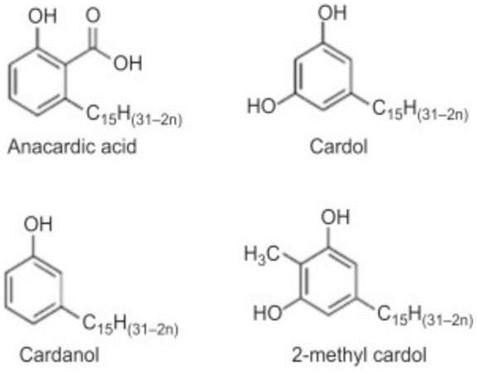

Figure 1.1 Major Components of Cashew Nutshell Liquid

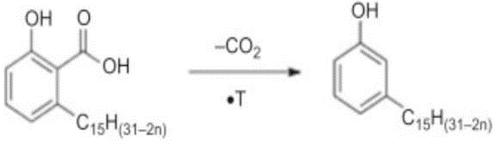

Figure 1.2 Conversion of anacardic acid to cardanol, where n = 0, 1, 2, or 3

As the chemical composition of CNSL changes depending on the extraction technology, two types of CNSL exist: natural (CNSL) and technological [60] CNSL. [61] Soxlate, supercritical carbon dioxide, or subcritical water may be used to extract the natural CNSL without causing any chemical modifications to the product. Phenol/formaldehyde polymers may be made using chemicals obtained from the Technology CNSL. There has been an increase in the availability of phenolic components due to new developments in the chemistry of these compounds. The CNSL is removed from the kernel by breaking the shell with high heat and recovering the cashews. CSNL's thermal stability is improved by the presence of aromatic rings, making it an effective fire retardant. Formaldehyde reacts with the aromatic and phenolic compounds in CNSL to make hardening polymers like as resole and novolac, which may be used as the matrix resin for alloys. CNSL side chains may also be polymerized using free radical initiators or ionic initiators. Enhancing the healing qualities of formaldehyde resins by adding the hardening agent Hexamethylenediamine (HMTA) has been done. Due to the inclusion of aromatic and phenolic components, CSNL can generate novolac and resole, two thermosetting resins used in bio composites, without the usage of formaldehyde.

The longer hydrocarbon chains in Novolac CNSL formaldehyde resin hardeners make them more flexible than the hardeners in traditional phenolic resins. They may be used to coat surfaces that need great chemical resistance, whether the oil changes.

The CNSL thermal material is reinforced with natural fibers. A variety of fibers have been employed in previous studies, including palm oil fibers, kenaf, hemp fibbers, coconut fiber, and sisal. Look into various CNSL-based materials to determine their mechanical characteristics and make comparisons.

Researchers say that CNSL components have structural features that enable them to be transformed into compounds and high-value polymers. Chemical transformation yields materials that are chemically pure while also increasing the product's value. It's this vast range of alternatives and unique chemical options, together with high-value goods and polymers, that CNSL provides.

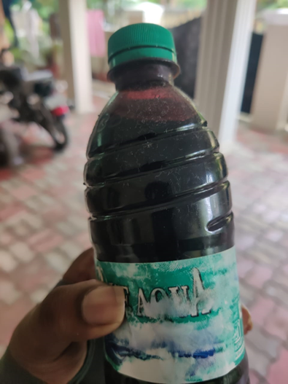

Figure 1.3 Uncracked CNSL

* 1. **Properties**
* Phenol at a Low Cost
* Polymerization and chemical modification versatility Possibilities for high-performance polymer development
* Certain properties give it an advantage over phenolics in certain applications, such as impact resistance, flexibility, faster heat dissipation, and so on.
* Liquid Resin PF Resin Cashew Friction Dust is a type of brake lining used in automobiles (CFD)
  1. **Reactivity**

The CNSL goes through all the normal final reactions. Only the C15 side chain separates the cardinal from the phenol. It goes through a well-known extraction reaction of formaldehyde of phenols, which produces phenolic polymers. Furthermore, it can be polymerized by side chain dissatisfaction, whereas the gross nature of the side chain limits the molecular weight that can be achieved by oligomers. An important advantage of Cardanol is its ability to chemically modify to produce the desired structural changes to obtain specific properties to make custom-designed high-value polymers. As a result, structural changes can be made to the hydroxyl group, aromatic ring and side chain.

* 1. **Industrial Significance of CNSL:**
* Low-cost final.
* Versatile ingenuity of polymerization and chemical modification.
* Opportunities to develop high-performance polymers.
* Property advantages over finals in some applications such as impact resistance, flexibility, rapid heat dissipation etc.
  1. **Advantages of CNSL based Polymers:**
* Adaptability and fragility have been gotten to the next level.
* Natural Solvent Solubility
* Processability has been gotten to the next level.
* Rubbing has low blur attributes.
* 'Cold Wear' obstruction.
* Great electrical obstruction.
* Further developed Water Repellency.
* Salt and corrosive obstruction has been moved along.
* Similarity with different sorts of polymers.
* Antimicrobial action.
* Protection from termites and bugs.
* Underlying Characteristics for Polymerization into High-Performance Polymers
  1. **Applications of CNSL:**
* It is profoundly impervious to grating linings, paints, stains, overlay pitches, composite elastic tars, cashew concrete, polyurethane based polymers, surfactants, epoxy, and water impervious to synthetics. Gums, foundry synthetic compounds and substance intermediates. CNSL gum is broadly utilized as a base covering part because of its incredible protection from water and synthetic substances.
* CNSL is utilized as an option in contrast to linseed oil in the production of foundry centre oil utilized as a fastener in fashion.
* Basic and corrosive arrangements, mineral and greasy oils and different natural solvents forestall warming of adjusted CNSL burner lacquers within the sight of explicit gas pedals.
* CNSL is an astounding natural substance for against consumption covering details.
  1. **Disadvantages of Biofuel**
* As an energy some downsides of biodiesel are as follows
* Advanced density that causes energy atomization problems and injectors choke.
* It contains low energy content and a high pall point and a point of pouring over
* diesel come problematic for storehouse and running.
* Since biodiesel having low energy content, machine affair similar as energy effectiveness,
* strength and necklace can be dropped by 8 to 15 relatives to diesel.
* Biodiesel released NOx advanced than diesel energy.
* Biodiesel costs are still a big concern.
  1. **Objectives**

The proposed exploration was performed using linseed canvas biodiesel with the following pretensions.

* Biodiesel extraction through transesterification process from CNSL Oil.
* Determination of density and viscosity of diesel, and different composites in agreement to applicable ASTM norms.
* Machine setup medication for energy testing and gas analyser for emigration testing
* Performance analysis for different composites rate Diesel, TC CNSL, and TC CNSL + Al2O3 biodiesel for different affair parameters.
* Assessment for different composites of linseed biodiesel for different emission characteristics similar as smoke density, HC, CO2, CO, and NOx with comparison of results to conventional diesel.

**CHAPTER 2**

**LITERATURE SURVEY**

**2.1 Manzoor Elahi M. Saud agar** et al, the point of this study was to figure out how nano-increments of silicon dioxide (SiO2) to soybean biodiesel influence the general presentation and emanations of a diesel motor running on it. Biofuels are produced using soybeans utilizing transesterification innovation. The morphology of nanoscale parts is concentrated on utilizing checking electron microscopy (SEM), X-beam diffraction (XRD) and energy-dispersive X-beam spectroscopy (EDS). For homogeneous blending of nano- added substances with biodiesel, ultrasound was utilized, and surfactant was utilized to balance out the nano-added substances. ASTM principles were utilized to test the physical and compound boundaries of unadulterated and blended fuel tests. The general presentation and outflow attributes of a few fuel tests were tried under various burden conditions. The utilization of SiO2 nanoparticles added substances expanded brake warm productivity (BTE) and brake explicit fuel utilization (BSFC) by 3.48-6.39% and 5.81-9.88%, individually. Smoke discharges for carbon monoxide (CO), hydrocarbon (HC), and nano- added substance compounds were diminished by 1.9 - 17.5 percent, 20.56 - 27.5 percent and 10.16 - 23.54 percent, separately, contrasted with the SBME25 fuel blend.

The incorporation of nanoparticles diminishes outflows like carbon dioxide, hydrocarbons, and smoke as well as nitrogen oxides. NOx levels increment as the ignition chamber temperature builds because of complete burning. Whenever SiO2 nano added, substances were added to the soybean biodiesel mix, BTE expanded by 3.48-9.12 percent however BSFC diminished by 5.81-11.58 percent. Carbon dioxide, hydrocarbon and outflows emanations of nano-added substance compounds were decreased by 1.9 - 17.5 percent,

20.56 - 27.5 percent and 10.16 - 23.54 percent, individually, contrasted with the SBME25 fuel blend. In any case, because of the utilization of silicon oxides and the presence of oxygen in the biodiesel, the NOx levels for all nanofluid composites increment fairly because of the expansion in chamber temperature and the presence of countless oxygen molecules.

**2.2 Ashok Kumar** et al, the objective is to figure out how cashew oil corn meal 80% of the diesel range and 20% of CNSO at explicit infusion pressures (IP) of 200, 220 and 240 bar, separately. CNSO is presently one of the most outstanding elective revaluations, like the most affordable and unappetizing nature reassessment. 4. With an appraised force of 4 kW and a steady speed at 1500 rpm, the test was performed on a four-stroke, single-chamber diesel motor utilizing cashew shell diesel oil total. The burning examination impact of test energizes on net intensity discharge rate, chamber pressure, brake explicit fuel utilization (BSFC), brake warm effectiveness (BTE) and chamber temperature was assessed during the general presentation test. Exploratory outcomes at 220 bar IP, BTE expanded yet BSFC diminished for complete diesel from cashew oil. With 220 bar IP, the murkiness of hydrocarbons, carbon monoxide and smoke are altogether diminished, even though carbon dioxide and nitrogen oxides are showing expanding patterns.

The fundamental physical and compound boundaries of CNSO are planned utilizing customary techniques contrasted with diesel. At the Redwood Viscometer, CNSO diesel amalgams were assessed for thickness at 400 C. The thickness of gas in a CI motor in chilly climate is viewed as crucial. Changing the fuel rate, as it is commonly known, essentially affects the ignition coefficients of the combination.

Numerous burning attributes, for example, start delay, tension inside the chamber, heat discharge rate, and most extreme strain increment, are analyzed to perceive what IPs mean for diesel motor ignition. By and large, the start delay abbreviates the IP address further. This is on the grounds that an IP of more than 240 bar permits more fuel to enter the motor chamber in a more limited timeframe, running clean air with surrounding power devices and wasteful ignition. At IP levels higher than B20-220 bar, infusion of a lot of fuel in a brief timeframe bringing about unfortunate ignition can prompt inappropriate blending of the fuel-air combination. Considering the aftereffects of the trial, they saw that at a particular limit of 240 bar IP, there were inversion patterns as well as decreased engine execution.

**2.3 H. N. Dike** The need to transform squander into abundance has prodded this examination. Most of the results delivered during cashew handling are delegated squander and delivered into the climate. Cashew shell fluid, a dull fluid containing normal and regenerative phenolics, is found in the garbage bin (CNSL). Because of the phenolic content and underlying elements of CNSL, normally happening and changed cellulose-based home-grown polymers have been incorporated and utilized alternative for engineered and petrol-based polymers in a wide assortment of uses. The work is discrete, manipulative, and Natural liquid removed from cashew shells as an added substance to penetrating fluid plans. Sox light hardware, CH3)2CO and cashew shells were utilized in the concentrate as dissolvable extraction strategies. The fluid concentrate goes through a comparative change when amines are added. 100 mL of cashew shell, 7.3 mL of ethanolamine, 27.58 mL of diethanolamine (DEA), and 38.2 mL of triethanolamine were added to the cementing system (TEA). At temperatures from 100 to 140 C, the mixtures were sulphated with sulfamic corrosive as an impetus. The response combinations were blended consistently for 1 h and as a response result, esterification water was gathered, which addresses the complete response. Biodegradable, reasonable, and regenerative esters have been distinguished. To decide the synthetic piece of esters, a natural examination was performed utilizing the FTIR gadget. The FTIR concentrate on showed that the altered mixtures contained N-H and C-H extending vibrations, which were absent in the CNSL, demonstrating the development of new mixtures. The physical and substance properties of the concentrate were analyzed, and the outcomes were reliable with past investigations. When joined with the right materials and conditions, these materials can possibly become multifunctional penetrating added substances. This decreases the expense of bringing in manufactured oilfield synthetics while making position and assisting with accomplishing the neighbourhood content objective.

Removed utilizing CNSL Solvent Extractor. Because of its capacity to deliver 95-the vast majority of fluid from a strong shell, CH3)2CO was chosen as the dissolvable and process. The physical and synthetic properties of the focal sensory still up in the air. The iodine esteem demonstrates the presence of an unsaturated carbon chain in the concentrate, while the acidic worth shows the presence of a carboxylic corrosive gathering in the CNSL separate. Thus, the pH of CNSL came to (4.49), demonstrating the presence of anacardic corrosive, which is expected for the development of numerous synthetics. The number is somewhere close to 4.6 and 5. The pH showed that the separated CNSL was typical because of the extraction interaction. The useful gatherings present in the CNSL are resolved utilizing the FT-IR range after being synthetically denotated within the sight of a suitable impetus. The presence of these gatherings demonstrates that the CNSL was adjusted to create new atoms. Accordingly, they contend, these materials could be potential multi-reason added substances in boring tasks when joined with proper added substances and conditions. This diminishes the expense of bringing in engineered oilfield parts, while simultaneously expanding the potential for business and advancing neighbourhood content focusing on.

**2.4** **Michael J. Pedder and partners** are doing investigate on an assortment of biofuels. Biodiesel is supposed to turn into an option in contrast to diesel fuel. Albeit unadulterated biodiesel can be utilized in diesel motors, it has a few impediments that keep it from totally supplanting standard diesel, for example, higher thickness, lower cetane reach and lower calorific worth. Subsequently, biofuel mixes are liked for use in diesel motors. Subsequently, this exploration looks at different ways to deal with nanoparticles execution in biofuel amalgamation, as well as the impact of nanoparticles in biodiesel and diesel combination on in general motor execution, burning examination and outflows qualities. Remembered for this assessment study are the consequences of past examination on the potential and use of nanoparticles in bioethanol creation, as well as the effect of adding nanoparticles to diesel fuel with various proportions of biofuel. Different methodologies are being examined to further develop motor execution. Nanoparticles can be utilized as impetuses in the creation of biofuels from feedstocks preceding synthetic responses. By and large outcomes show that the expansion of nanoparticles essentially decreased the fuel utilization of the brakes by 20% to 23% contrasted with biodiesel and diesel blends with liquor or added substances. Also, the utilization of nanoparticles further developed the burning system and expanded the breaking power from 2.5 to 4% because of their high warm conductivity. Information showed that outflows of nitrogen oxides expanded by 55% during most appraisals, while discharges of hydrocarbons, carbon dioxide and particulate matter diminished essentially. Research has shown that the utilization of extra nanoparticles with a combination of biodiesel and biodiesel as fuel in the CI motor can effectively run the diesel motor and give higher in general execution and controlled outflows.

The blend of current biofuel creation techniques and nanotechnology will prompt a reasonable and mediocre synthetic response that will limit the unsafe impacts of different solvents and impetuses utilized in biofuel creation and furthermore decrease the expense of biofuel creation. Most properties of fuel This can be improved by adding NPs. Hence, cautious determination of NPs and their suitable measurements is expected to survey the effect of utilizing NPs on DICI diesel motor execution, ignition, and discharge attributes. The physical and substance properties of the fuel utilized, as well as its piece, ought to likewise be checked. In DICI diesels, the utilization of biodiesel or diesel fuel with biodiesel and ethanol can marginally decrease BTE while further developing BSFC. Then again, poisonous exhaust outflows can be fundamentally diminished. Biodiesel ethanol mixes altogether further develop BTE, yet essentially diminish BSFC, without the utilization of NPs with diesel. Furthermore, unsafe emanations, for example, HC, CO, and PM can be fundamentally decreased. Adding NPs to most of diesel, biodiesel, diesel, biodiesel, and ethanol mixes utilized in DICI diesels fundamentally further develops execution in most of pilot tests. Expanding the centralization of NPs did not bring about execution acquires corresponding to the quantity of NPs added, as per a few examinations. Thusly, finding the ideal exhibition improving impacts in deciding the ideal sort, size, and focus proportion of NPs is of most extreme significance. At last, the utilization of NPs in DICI diesel motors further develops execution while lessening perilous discharges.

**2.5 Jeevan Kumar** and partners in the modern and transport areas said oil utilization was developing quickly. It is for the most part expected that an expansion in the interest for non-renewable energy sources later will prompt a decrease in oil-based commodities. Biofuel is a fuel made by blending liquor and vegetable oils, fats, or lubes, including café oil, which has recuperated in a compound response. Metal-based parts are utilized in IC motors to further develop fuel quality by diminishing flammable hydrocarbons and decreasing destructive outflows from the exhaust fuel line. The ebb and flow research objective are to figure out how the expansion of aluminium oxide and copper oxide nanoparticles to Mahua biodiesel influences the exhibition of the water-cooled four-stroke diesel motor. Trials will be led first to work on the ignition, by and large execution and discharge qualities of the mahogany oil and diesel fuel combination. Ultrasound produces nanofluids freely of 50 ppm aluminum oxide and copper oxide. Impact of nano-added substances on chamber pressure, heat discharge rate and general execution estimations like BTE and BSFC, as well as ignition qualities like outflow boundaries. Emanations of nitrogen oxides of hydrocarbons, carbon dioxide, carbon dioxide and mahogany oil are estimated and looked at. The utilization of biodiesel in CI motors altogether decreases particulate outflows. The incorporation of oxygen-rich substances in biodiesel expands the creation of nitrogen oxides. In this study utilizing nano-added substances, there was a critical decrease in NO discharges because of chamber temperature control.

Contrasted with running clean diesel, the chamber pressure and HRR of Mahua biodiesel were diminished by 4% and 3.07%, individually, because of the lower warming worth of biodiesel. Because of the decreased unpredictability and thickness of Mahua biodiesel, BTE expanded somewhat because of diminished heat misfortune, while BSFC expanded by 2.5%. Whenever Mahua utilized biodiesel rather than diesel, hydrocarbon discharges fell by 16.2 percent, carbon dioxide outflows by 11.4 percent and carbon dioxide emanations by 5.2 percent. At the point when Mahwah fuel is utilized rather than diesel, NOx emanations increment by 8.4 percent at evaluated load. Biodiesel has higher chamber temperatures because of the presence of oxygen, which brings about better NOx cells. Mahua biodiesel gets more oxygen by utilizing nano-added substances, which improves its ignition properties and molecule emanations.

**2.6 Prabhu A** et al, Analyzed the exhibition, ignition, and emanation attributes of a solitary chamber direct infusion (DI) diesel motor utilizing three fuel chains: biodiesel-diesel (B20), biodiesel-diesel-nanoparticles (B20A30C30), and Nanoparticles (B20A30C30) (B100A30C30). The ultrasonic gadget is utilized to deliver nanoparticles like aluminium oxide (Al2O3) and cerium oxide (CeO2) blended in with the fuel combination at 30 ppm to create a uniform suspension. Because of the huge surface region/size proportion properties of the nanoparticles the degree of blending and synthetic response during ignition increments, bringing about superior diesel motor execution, burning and outflow qualities. Contrasted with the B100, the dispersant test fuel (B20A30C30) motor brake warm proficiency worked on by 12%, bringing about a 30 percent decrease in NOx emanations, a 60 percent decrease in CO outflows, a 44 percent decrease in hydrocarbon discharges and a 38 percent decrease in carbon monoxide emanations. The exhibition, ignition and discharge attributes of nanoparticles-scattered test powers are investigated in a solitary chamber consistent speed diesel motor.

There is a critical expansion in the warm effectiveness of the brakes contrasted with the B100 test fuel with the nanoparticles scattered test fuel. The nanoparticles in the biodiesel diminish the start delay and speed up the beginning of burning, bringing about lower heat delivery and chamber tension at full burden.

Scattering test fuel B20A30C30 shows a huge expansion in nanoparticles generally motor execution and outflow qualities.

For the B20A30C30 test fuel, the high-level redox process utilizing nanoparticles brings about a limit of 60% CO2 decrease, 44% UBHC decrease and 38% smoke obscurity decrease.

As a rule, the utilization of alumina and cerium oxide particles in the biodiesel combination as an added substance increment's motor presentation, burning qualities and emanations without the requirement for any progressions in the motor.

**2.7 Edwin Jiu** et al, and associates run a one-chamber piezo start motor that sudden spike in demand for rich cashew shell oil, diesel and CNSO methyl ester. The trials were then acted within the sight of CNSO with a combination of oxygenates, liquor and vegetable oils. The general presentation, emanation, and ignition qualities of the motor, as well as the advantage from those blends, are practically identical to the base fuel while working at full power yield. Considering the trial results, the accompanying ends were drawn. Of the oxygen compounds considered, diethyl ether composites are better than dimethyl carbonate amalgams concerning by and large execution. The warm slowing down proficiency of the DEE30 (29.68%) is like that of a diesel running at full burden (30.14%).

The analysis utilized a solitary chamber, four-stroke, water-cooled direct infusion diesel motor. Motor determinations are accessible. To decide the strain inside the chamber, a piezoelectric transducer is put in the motor chamber. A swirl current dynamometer was added to apply the heap and to gauge the motor's power yield at various burdens, and the TDC (position of the wrench that holds the cylinder when the chamber size is tiny) was fixed at the wrench point. A high velocity information assortment module was utilized to report pressure wrench point information. Gadgets associated with a tension transmitter were utilized to screen air admission and diesel utilization. The "motor programming" programming was joined to the motor utilizing the fitting equipment, implying that the sensors and transducers gave the product the information expected to compute the general presentation measurements. AVL (Install for Verbrennungskraftmaschien) 5 Fuel Line Analyzers are utilized to screen discharges of CO2, NOx, CO, and hydrocarbons at different motor burdens. A Bosch smoke meter was utilized to screen smoke emanations. As per the TRIA results, the motor's best presentation is DEE30 in oxygenates, BUTANOL30 in alcohols and CMPRO30 among various vegetable oil blends provide the best engine performance. Among these three fuels, DEE30 and CMPRO30 provide engine performance, combustion, and emissions comparable to standard diesel engines. This is carefully accompanied using BUTANOL30.

**2.8 W.M. Yang** et al, in this study, CNSL, an economically viable feedstock for some of the various modern-day resources, was considered for the best supply of alternative fuel. In this case, CNSL is extracted from a waste product, cashew nut outer shell, using a completely unique steam treatment procedure aided by the mechanical crushing technique. In contrast to previous studies that attempted to use unprocessed CNSL as an alternative for diesel at the same time, this study used processed CNSL after cracking it with a zeolite catalyst. As a result, each extraction of CNSL from cashew nut outer shell and processing of it through the catalytic cracking procedure to help synthesize CC-CNSL (catalytically cracked CNSL) is distinct, emphasizing the significance of the current work. Following the implementation of such distinct methodologies for fuel characterization, the properties of CC-CNSL, such as viscosity and calorific value, were discovered to be improved. Following that, CC-CNSL20 (20% -CNSL and 80% diesel) was tested at various fuel injection pressures, including 200 bar, 235 bar, 270 bar, and 300 bar, to optimize its use in a single-cylinder diesel engine. Based on the engine experimental study, the CC-CNSL20 was found to have higher engine overall performance than diesel, and the composite emissions of CO (carbon monoxide), HC (hydrocarbon), NOX (oxides of nitrogen), and smoke were found to be higher than diesel and in compliance with the legislative norms for Genset. This research work has been initiated within the proper accord with the goal of improving the fuel properties of CNSL, an economically feasible alternate fuel derived from cashew nut outer shells, to facilitate its effective use in a diesel engine. After discovering that catalytic cracking of CNSL had previously been impossible, we cracked it with the use of zeolite as a catalyst and, most notably, a distinct method of steam treatment process accompanied by mechanical crushing was used to extract CNSL from cashew nut outer shells. Both extraction and processing strategies appear to have had a positive impact on fuel properties, increasing the viscosity and calorific value of the synthesized CC CNSL. According to the analysis, the composite emissions, calculated using the ISO 8178 D2 standard test cycle, were found to be well within the legislatively mandated limit of Genset for CC-CNSL20. Other than optimizing fuel injection parameters, engine layout, combustion bowl geometry, compression ratio, and nozzle hole geometry will be changed in the future to successfully use better CC-CNSL blends in a diesel engine.

**2.9 I. Tankoano** et al, this study demonstrates how to generate energy from cashew waste by making briquettes from the press cake left over after removing the CNSL from the nut shell. The press cake is carbonized at 350 °C and ground to a grain size of 0.5 mm using this technique. The resulting charcoal powder is then combined with water and a binding agent (cassava starch), which was chosen due to its physical-chemical properties, availability in the local market, and low cost. The resulting mixture is then densified in a screw press to produce briquettes with 5.5 cm diameters and 10 cm lengths. Several water and cassava starch proportions were tested, and the best briquettes were obtained with a mix of 35% water, 10% cassava starch, and 55% press cake charcoal. After mechanical and physicochemical testing, briquettes had a net calorific value of 25.7 MJ/kg, a density of 0.91, a compressive strength index of 382.89 kPa, and an impact resistance index of

61.10. Following a water boiling test, the briquettes demonstrated the same combustion capability as wood charcoal.

The purpose of this study was to create briquettes from cashew press cake. The findings indicate that it is possible to create briquettes with acceptable physical-chemical and mechanical properties for burning that can be used to replace traditional biomass. Briquettes have significantly higher calorific values than wood and are comparable to charcoal. The use of a binder (starch) influences the parameters in the proximate analysis; the maximum rate evaluated in this study had the lowest mechanical calorific value of ten percent (10%) of starch, resulting in the best chemical and mechanical qualities. The combustion of briquettes produces a high-quality flame. A comparison of briquette and charcoal thermal yields revealed that the thermal efficiency of the briquette-fired fireplace (33.9 percent) was comparable to that of charcoal (33.7 percent). Following the completion of the tests, two briquette varieties (B.30.10 and B.35.10) were chosen. Finally, briquette

B.35.10 was chosen as the best in our briquette use conditions due to its mechanical properties, particularly its ability to withstand shocks during transport. Shortening the carbonization period and testing in industrial boilers could improve these results.

**2.10 Colin J. Barrow** et al, they defined distilled technological cashew nut shell liquid (DT-CNSL) as a non-trans esterified biofuel and an additive for converting triglycerides to biofuel without producing methyl esters. Diesel DTCNSL blends meet diesel physicochemical requirements. DT-CNSL improves the stability of diesel blends containing straight vegetable oil (SVO) and tallow oil. Fluorescence tests using charge transfer probes show that the DT-CNSL, triglycerides, and diesel mixture is a homogeneous solution with fluorescence behaviour comparable to diesel. The economics of cashew (Anacardium occidentale) production, industrial application, and strong carbon sink qualities imply that DT-CNSL could supplement or replace traditional biodiesel crops such as Jatropha, increasing farmer income. Transesterification is not required with the DT- CNSL. Reduced pollution, increased job development, proper land utilization for both food and biofuel production, and increased farmer revenue are all potential benefits. It may also be able to make alcohol from cashew fruit, implying that there is potential for increased biofuel generation from cashew. DT-CNSL is a viable substitute for traditional trans esterified biofuels. DT-CNSL is not technically biodiesel, but its ability to substitute standard biodiesel makes it an intriguing biofuel. DT-CNSL increased triglyceride solubility in diesel, which is most likely due to DT-CNSL acting as a nonionic detergent. Adding DT-CNSL to a three-component mixture of diesel, triglycerides, and DT-CNSL results in a homogeneous liquid, according to stability and fluorescence studies. When compared to growing Jatropha as a non-food biofuel crop, growing cashew as a food and biofuel crop has the potential to increase farmer revenue. Given the uncertainty surrounding Jatropha's future as a biofuel crop, cashew offers a unique alternative that could increase farmer revenue while providing both food and biofuel in a single crop.

**CHAPTER 3**

**PROBLEM DEFINITION**

For transportation and industrial transport vehicles, diesel fuel is the preferred fuel. Diesel fuel is not as refined as gasoline, and it does not have the same flammability or refinery adultization regulations. The ability of the fuel to ignite is hindered by low cetane. Higher fuel consumption, power loss, greater emissions, and detonation wear are all effects. Hard starts and fuel gelling are caused by wax and sludge, as are blocked injectors and filters, pump damage, and high emissions.

**3.1 Generations of Biofuel**

* **First Generation Biofuel**

First generation biofuels are mostly composed of sugar, starch, and vegetable oils. Fuels like ethanol, propanol, and butanol may be created by microorganisms and enzymes by fermenting sugars, carbohydrates, and cellulose. Biofuels from the first generation of technologies are significant, but they can only generate so much fuel at a particular time before causing damage to the food supply and biodiversity. Subsidies, lack of pricing competition, and poor reductions in greenhouse gas emissions are some of the problems faced by first-generation biofuel technologies. As far as life cycle estimations are concerned, first generation biofuels beat traditional fossil fuels when production and transportation emissions are taken into consideration.

* **Second Generation Biofuel**

Second generation biofuels, often referred to as green olive oil or cellulosic ethanol fuel, are mostly made from non-dietary or propellant feedstocks. The main raw material to produce second-generation biofuels is waste vegetable oil, forest residues, industrial residues, and sustainable biomass.

* **Third Generation Biofuel**

Because it is made from algae, third-generation biofuels are also known as algae fuel or oil. Algae biofuels allow the production of a wide variety of biofuels, including gasoline, butanol, propanol, and ethanol, yielding almost ten times more than second generation biofuels. Cultivation of biomass for third generation biofuels also contributes to the ecological balance by absorbing carbon dioxide from the atmosphere.

* **Fourth Generation Biofuel**

Fourth-generation biofuels were made possible by advances in the fields of carbon capture and storage, plant biology, and biotechnology (metabolic engineering). Advanced biofuel manufacturing processes are needed to meet these needs. As a carbon capture device in this generation, bioengineered plants, trees, and algae use their leaves, twigs, and other parts to store carbon for use in the production of biofuels.

Due to the existing Biofuel, there is an emission of many types of gases which causes pollution. So, by adding CeO2 as nano additive we are working on it to reduce emission and performance characteristics through our biofuel.

**CHAPTER 4**

**METHODOLOGY USED**

**4.1 Cracking of Oil**

Heat, pressure, and occasionally catalysts are used to break down heavy hydrocarbon molecules into lighter ones in the process of cracking. Frocking is the most critical phase in the industrial manufacture of gas and diesel. During the process of petroleum cracking, light oils (like gas), medium oils utilized in diesel fuel, heavy residual oils, stable carbons (coke), and gases such as methane and ethylene are created. Depending on the eventual result, the oils may be redirected straight into gas blending or refined further by cracking or other methods. For the refinery's gas system, gas may be utilized to produce synthetic rubber and plastics, as well as a range of agrochemicals, which can then be sold to the public. It is possible to break big, heavy hydrocarbon molecules into smaller, lighter fragments for commercial or personal usage via the cracking process. Frocking is a critical step in the refinement of crude oil. There are several more petroleum products that are made by cracking, including heating oil, diesel fuel, and gasoline.

In oil refineries, cracking is performed to remove marketable by-products from crude oil. Sweet light crude, for example, requires minimal refining before being sold. The relative value of goods such as heating oil and gasoline may change over time based on variables such as the frequency of production of various petroleum by-products because commodity traders have predictable and hedging capabilities. Although crude oil can be processed into many products, the two most frequently traded commodities in commodity markets are heating oil and gasoline. Because supply and demand change relative prices over time, traders often use the rule that the ratio between them is subject to fluctuations between 3 and 2 to 1. In other words, three barrels of oil provides two barrels of gasoline and one barrel. Heating the oil according to this ratio. Traders can try to bet back to the average by buying an item that is relatively low and selling items that look expensive when prices change significantly from these ratios. This ratio can also be used as a guide by traders trying to prevent exposure to various commodities.

* **What is the crushing process?**

Crude oil consists of a complex mixture of large and complex hydrocarbon molecules after recovery from the well. Despite the value of crude oil in the unprocessed state, its economic consumption is limited until it is further refined.

Although cracking is a common step in the oil refining process, some oils, such as light sweet crude oil, require minimal processing before being sold. Such oil forms are widely sought after and are gaining high prices in international commodity markets due to the modest amount of investment required before sale. Heating oil and gasoline, the two most widely used crude oil products, are traded in the commodity markets. Traders use the inference that the ratio between them usually varies between 3 and 2 to 1 even though their relative prices change over time due to supply and demand.

**4.2 Thermal Cracking**

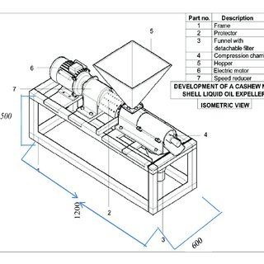

Figure 4.1 Thermal Cracking Machine Layout

Thermal cracking is the process of splitting long-chain, high-melting hydrocarbons into short-chain, low-melting hydrocarbons by subjecting them to extreme heat and temperature. Pyrolysis has been studied for over a century and pyrolysis (to make coke) of coal has been used commercially for a long time. Ethane and other heavy hydrocarbons are usually hydrolyzed to form ethylene and propylene. Butadiene and BTX are also produced in large quantities using this process (benzene, toluene, and xylene). In addition, acetylene, isoprene, styrene, and hydrogen are formed and can be recovered if economic conditions permit. Warm breaking is the method involved with parting long-chain, high-dissolving hydrocarbons into short-chain, low-softening hydrocarbons by exposing them to outrageous intensity and temperature. This method is utilized to gather parts or valuable parts delivered during the devastating system. Warm breaking is the method involved with separating sub-atomic bonds and changing over unrefined petrol hydrocarbons into short- chain, low-bubbling hydrocarbons by openness to high intensity and high temperature. Warm breaking has been read up for more than a really long period, however the pyrolysis of coal (for coke creation) has been read up for quite a while. Ethane and weighty hydrocarbons are typically hydrolyzed to frame ethylene and propylene. Enormous amounts of butadiene and BTX (benzene, toluene, and xylene) are additionally delivered. Besides, acetylene, isoprene, styrene, and hydrogen are created and can be recuperated if financial circumstances permit. Pyrolysis is utilized to make ethylene and propylene from ethane and weighty hydrocarbons. Butadiene and BTX (benzene, toluene, and xylene) are likewise delivered in enormous amounts. Likewise, acetylene, isoprene, styrene, and hydrogen are shaped and can be recuperated assuming that financial circumstances grant.

Ethylene and propylene are generally utilized as feedstocks in numerous petrochemical processes, as well as in the production of modern plastics and high atomic weight polymers. Ethylene is orchestrated in the lab and extricated from light paraffins (isolated from flammable gas), or ethanol taken from the pre-maturation process for oil parts. It was made financially from coke broiler gas that started during the 1920s and went on for a long time from that point. Coal handling innovation and resulting coal-determined hydrocarbons established the groundwork for the improvement of warm breaking advancements for petrol and flammable gas feedstocks. A bunch of difficulties created as the treatment facilities got greater and greater. Accordingly, there was an expansion in petrochemical advancement. Interest for ethylene, propylene and fragrant accumulates has expanded because of plastics like polyethylene, polypropylene, and polystyrene. During the 1980s and 1990s, much examination was done to work on other ethylene and olefin creation processes. As feedstock, methane (a significant part of flammable gas), coal, methanol, waste, wood, and shale fluids were utilized. These unrefined components have no business utilizes. Current pyrolysis innovations and feedstocks are probably not going to be supplanted from now on. Ethylene creation has expanded altogether over the last 40 to 50 years. In the United States, ethylene creation expanded from 2.6 to 30 million metric tons each year somewhere in the range of 1960 and 2000, while propylene creation expanded from 1.2 to 14 million tons each year. Truth be told, financial circumstances in the United States and all over the planet during this period impacted the yearly development rate. In 2000, the world creation of ethylene was 88 million tons each year, with a limit of 104 million tons each year. In 1960, the United States created around 70% of the all-out ethylene and propylene delivered around the world.

As of late, relative development rates in ethylene and propylene creation have areas of strength for been Europe and Asia and even more as of late in the Near East. Just around 35% of all ethylene and propylene creation is currently delivered in the United States. In the treatment facility's reactant breaking units, enormous amounts of propylene are delivered as a side-effect. Propylene is here and there separated and reused for use as a feedstock at specific petrochemical offices. During the 1960s, specialists started examining the responses of reactor dividers during pyrolysis processes. More data about surface mechanics can be found in this article. This study investigates the warm breaking of propane in cylindrical reactors in warm breaking heaters. The model is worked starting from the earliest stage and assessed progressively by contrasting the reenacted results and information from the pilot plant. The exhibition of this rounded reactor was further developed utilizing the advancement cycle. Investigation of the impact of coke on assembling time and removal cost Dynamic and static circumstances. As per the contextual investigation, dynamic enhancement increments net benefit by 10.6% contrasted with base situation. Then again, dynamic advancement expects undeniably more figuring than static streamlining.

**4.3 Catalyst Cracking**

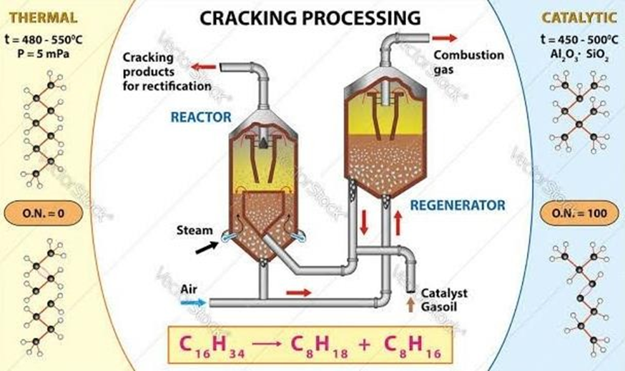

Figure 4.2 Catalytic Cracking

In petrol, reactant breaking is when petrol fume streams over a low-thickness impetus bed, compelling enormous parts to "break", bringing about lighter and more important items. It tends to be broadly utilized in the petrochemical field to make polyolefins. Impetus breaking is essentially tantamount to warm breaking, yet it utilizes an impetus (on a fundamental level) that does not utilize an impetus and keeps away from a considerable lot of the interaction programs utilized in processing plants to utilize the impetus to further develop execution. Innovation and Production Slate. During the devastating system, carbon tissue structures on the impetus, which fundamentally lessens its movement and silt expulsion can be basic. Breaking is the method involved with parting huge hydrocarbon atoms into more modest, more important hydrocarbon particles. The reactant cracking interaction happens within the sight of the impetus as the name suggests. The impetus advances the breakdown of enormous atoms such that increments benzene creation. All "feline break" articles ought to preferably be in the gas range, innovation forestalls this. The hydrocarbons created by cat breaks differ from methane to build-up. Strong impetuses effectively convert polymers into fluid powers in synergist breaks, bringing about gentle parts of warm breaking. The impetuses utilized in this cycle are silica-alumina, aluminosilicate zeolite (ZSM-5), and liquid synergist breaking (FCC). Plastic impetus breaks utilize less energy, and the decision of waste plastics permits breaking. Then again, the most energy-escalated approach is steam breaking. In oil, synergist breaking is the progression of oil fume onto a low-thickness impetus bed, constraining huge parts to "break" and creating lighter, more important items. There are three introductory stages in the synergist cracking cycle: response/recovery/division Hydrocarbon feed responds with the impetus at high temperature (around 900 ° F, 482 C) during the response stage and the break response starts. Coke is delivered during the devastating system. Coke covers the impetus and keeps the braking system from happening. The impetus is recovered during recovery by terminating coke stores on the outer layer of the impetus. In petrol, reactant breaking is the progression of petrol fume onto a low-thickness impetus bed, constraining enormous parts to "break" and delivering lighter, more important items. They are many times utilized in the petrochemical field to deliver enormous amounts of polyolefins. Impetus breaking is comparative on a basic level to warm breaking; however, it utilizes an impetus (hypothetically) that is not utilized all the while and is one of the numerous genuine applications that utilization the impetus to further develop process effectiveness and result yield. Processing plant. Carbonaceous material is saved on the impetus during the breaking occasion, which radically decreases its movement and residue expulsion is urgent. Carboniferous silt is shaped by the warm disintegration of polar iotas with high sub-atomic weight.

Synergist breaking is a technique for changing over an assortment of feedstocks, including gas oil, weighty raw petroleum, and build-up. Impetus breaking is comparative on a fundamental level to warm breaking; however, it utilizes a (hypothetically) impetus that is not utilized simultaneously and is one of the numerous genuine applications that utilization the impetus to increment process effectiveness and item yield. A processing plants. Impetus breaking is a business interaction that includes reaching the feedstock (generally the gas-oil part) with the impetus at the suitable temperature, strain and time. A huge part (> half) of the feedstock is hence changed over into fuel and low-bubbling items, which are generally single pass. Carbonaceous material is kept on the impetus during the breaking occasion, which diminishes its movement and residue evacuation is urgent. In feedstocks (bitumen parts and pitch parts) carbon stores are framed by the warm decay of high sub-atomic weight polar cells. Impetus stores are typically eliminated by consuming until impetus action is reestablished. The point of this part is to present reactant breaking processes with regards to their utilization and advancement in existing treatment facilities, as well as expected improvement in later treatment facilities. Look at the part. Get the book. In the field of raw petroleum refining, exhaust systems are much of the time used to change over thick feedstocks into more important naphtha and lighter items. Synergist breaking has to a great extent supplanted warm breaking with expanding interest for super charged fuel. The most concentrated and broadly involved reactant breaking strategy in fluid impetus breaking and hydrocracking raw petroleum refining A d impetus (typically zeolite with a typical molecule size of 70 m) consolidates with the disintegrated feed during the fluid impetus cracking interaction and assumes the properties of the liquid. The condensed impetus is persistently siphoned between the response zone and the recovery zone.

Many cycle developments are introduced as elective interaction choices, some of which use rucksack strategies (where one interaction is nearer to another); There are likewise extra open doors that poor person yet been sent off or are normal, however they are handily matched to the processing plant.

**4.4 Nano Additives**

Nanocomponents are used as catalysts with a biofuel mixture to improve overall performance parameters. Nano components increase BTE and BSFC, reduce SFC and provide higher torque while reducing cylinder temperature and frictional force. Adding nanoparticles to the biodiesel reduces the ignition delay and accelerates the start of combustion, resulting in lower heat release charges and cylinder fatigue at full load. If components are added to the biodiesel and diesel mixture, they can decorate the combustion level and lead to complete combustion. Due to their high oxygen content, diethyl ether, ethanol, methanol, and n-butanol can be used as biodiesel additives.

**4.5 Types of Nano Additives**

**1. Aluminium Oxide (Al2O3):**

Aluminium oxide, or Al2O3, is a chemical compound consisting of aluminium and oxygen. It is officially known as aluminium (III) oxide and is the most common of the various aluminium oxides. It is commonly referred to as alumina, but can also be referred to as alkoxide, alkoxide or alundum depending on bureaucracy or application. It looks like a sack that encloses with a drawstring. Al2O3 is often used in the manufacture of aluminium metal, as an abrasive and as a refractory material due to its high melting point.

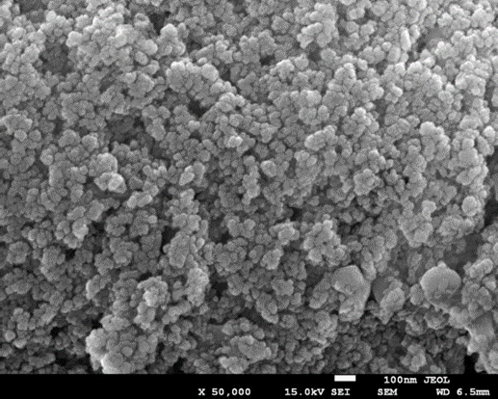

Figure 4.3 Aluminium Oxide

**2. Carbon Nano Tubes (CNT):**

A carbon nanotube is a cylinder made of carbon with widths estimated in nanometres. Single-walled carbon nanotubes Single-divider carbon nanotubes are a kind of carbon allotrope that is halfway between fullerene enclosures and level graphene, with breadths in the nanometre range.

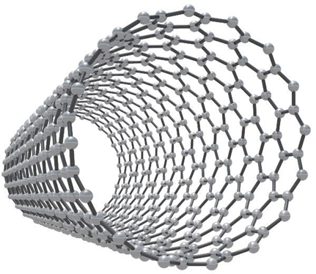

Figure 4.4 Carbon Nano Tubes

**3. Silver (Ag):**

Silver (Ag) is a shiny white metallic chemical element known for its decorative beauty and electrical conductivity. Between copper (period 4) and gold (period 6), silver is in group 11 (IBM) and period 5 in the periodic table, and its physical and chemical properties are up to half between the two metals.

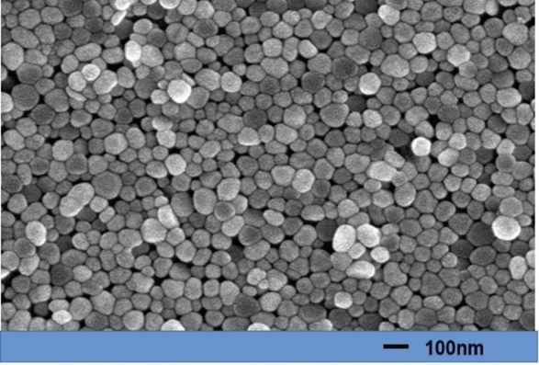

Figure 4.5 Silver

**4. Multiwall Carbon Nano Tubes (MWCNT):**

Carbon Nanotubes with Multiple Walls (COOH) Carbon Nanotubes with multiple Walls (OH Multi-walled carbon nanotubes (MWCNTs) are a type of carbon nanotube consisting of two single-walled carbon nanotubes nestled inside each other.

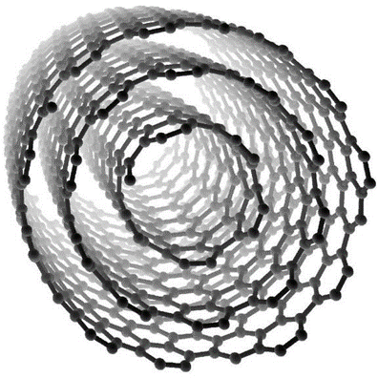

Figure 4.6 Multiwall Carbon Nano Tubes

**5. Zinc Oxide (ZnO):**

Zinc oxide is an inorganic compound composed of the elements Zeno. It's a white powder that's not soluble in water.

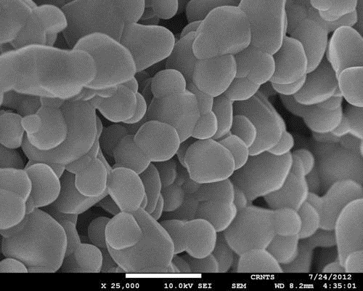

Figure 4.7 Zinc Oxide

**6. Cerium Oxide (CeO2):**

Cerium oxide the rare earth element is the oxide of cerium. Cerium oxide, cerium dioxide, ceria, cerium oxide and cerium dioxide are all names for the same substance. CeO2 is a white, pale-yellow powder with the chemical formula CeO2. It is a step in the process of extracting details from valuable commercial product as well as minerals.

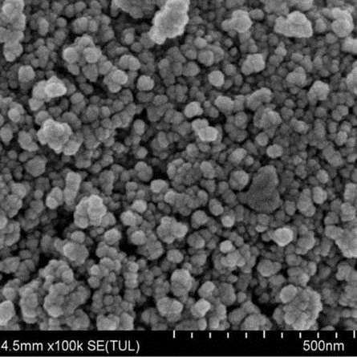

Figure 4.8 Cerium Oxide

**7. Copper Oxide (Cuco):**

Copper oxide is an inorganic compound in four different forms: Cu2O is the chemical formula for copper (I) oxide. Cuco is the chemical formula for copper (II) oxide. Cuco is a chemical compound found in copper peroxide.

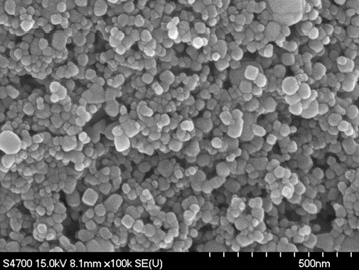

Figure 4.9 Copper Oxide

**4.6 Ultrasonic Method**

Homogenizers are ultrasonic mixers. All homogenizers dissolve the molecular bonds and allow the two compounds to combine completely. The strength used to soften such alloys varies; To distinguish between different types of homogenizers they are called mechanical (those that break cohesive bonds using physical forces such as anxiety, vibration, shear and / or impact), high pressure (those that use pressure) or ultrasonic. (Using pressure) (ultrasound) (using sound waves and cavitation) are used. Each type of homogenizer has advantages and disadvantages, depending on your application and resources. In this post we will look at the important benefits of using an ultrasonic mixer (also known as a so nicator) for your homogenization needs. All homogenizers can mix solid and liquid samples, and some can mix both; Ultrasonic mixers can achieve both. A cycle of alternating high and low pressure is created when ultrasound waves are used to create vacuum bubbles in the liquid medium. These bubbles grow and unite until they reach a certain size, during which time they collapse and shock the mixture (i.e., cavitation). Shock waves, as well as the vibrating tip of an ultrasonic mixer, break the cohesive bonds around the sample, making it a useful tool for dissolving a variety of materials.

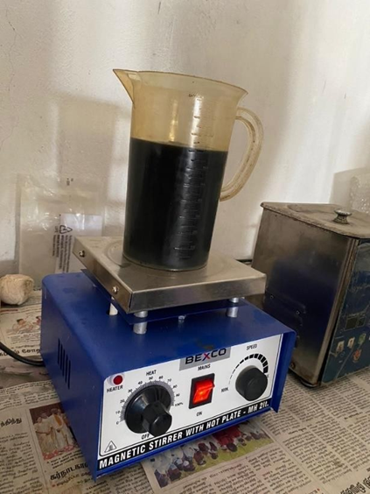

Figure 4.10 Ultrasonic Mixing

The performance of a homogenizer is influenced by a variety of factors. These variables include sample size, concentration, and temperature, as well as "agitator" shape, velocity, capacity, amplitude, pressure and duration, as well as medium temperature, viscosity and volume (as well as container type). These factors are difficult to change when using other types of homogenizers, but they are easier to adjust when using an ultrasonic mixer. In fact, technicians, scientists, and manufacturers may change any or all of these elements to allow for more sensitive or serious concern, depending on the scenario.

**4.7 Chemical Properties of CNSL**

|  |  |  |  |  |
| --- | --- | --- | --- | --- |
| **Synod** | **Characteristics** | **CNSL** | **CNSL Thermal Cracked** | **CNSL Thermal Cracked**  **150ppm** |
| **1** | **Kinematic Viscosity**  **@40°C in CST** | **10.38** | **6.78** | **6.81** |
| **2** | **Flash Point °C** | **248** | **46** | **48** |
| **3** | **Fire Point °C** | **256** | **57** | **59** |
| **4** | **Gross Calorific Value**  **KJ/KG** | **28,265.97** | **37,029.39** | **37,223.77** |
| **5** | **Density in KG/M3** | **996** | **889** | **892** |

Table no. 4.1 Chemical Properties of CNSL

**CHAPTER 5**

**EXPERIMENTAL WORK**

**5.1 Experimental Investigation of the Engine Performance Parameters**

Experimental engine tests were carried out in the automobile lab of Sri Venkateshwara Engineering Consultancy Services, Kancheepuram, on a CRDI VCR engine arrangement. The various tests were carried out on a single-cylinder, 4-strokes, and water-cooled VCR engine operating at constant speed of 1500 rpm with (cold) EGR or without EGR (Exhaust Gas 21 Recirculation) as indicated in Figure — for conventional diesel and different blends of linseed biodiesel. The various engine specifications are listed in the table — In this experiment, engine performance characteristics such as BP, BSFC, BTE, mechanical efficiency, and BMEP are investigated.

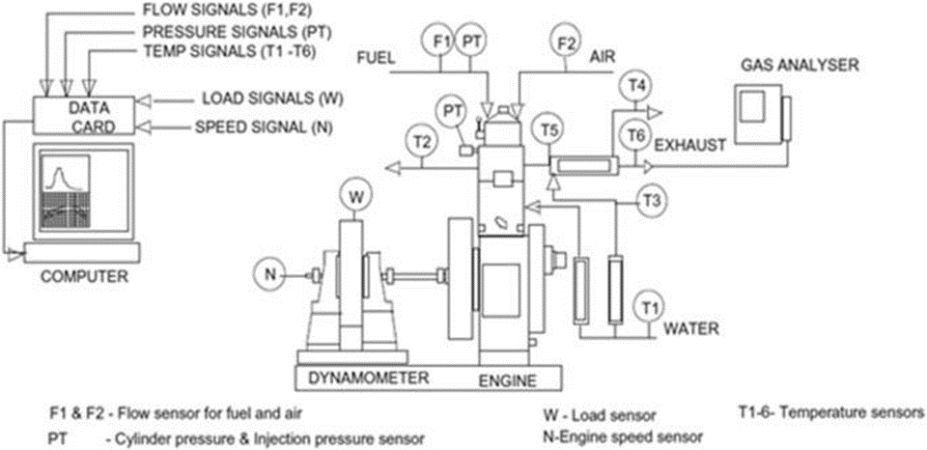

Figure 5.1 The CRDI diesel engine set up

**5.2 The technical specifications of the engine setup**

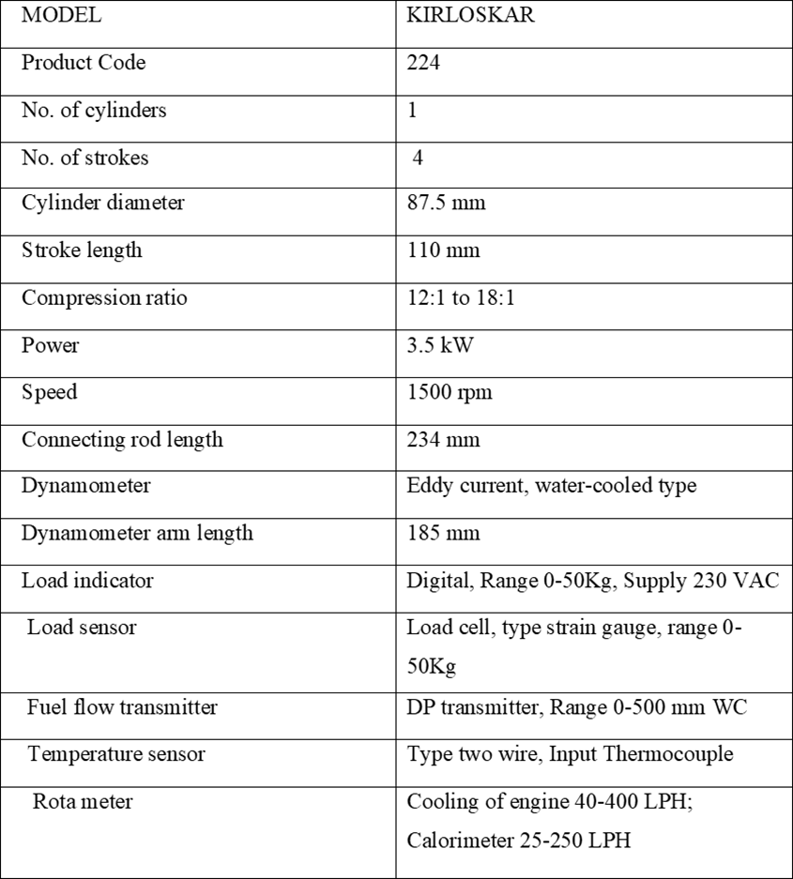

Table 5.1 The technical specifications of the engine setup

**5.3 Eddy Current Dynamometer**

There is a link between the engine and the eddy current dynamometer, which primarily measures power and torque. Several weights were applied to the CRDI engine using a dynamometer and a load cell, including 0kg, 3kg, 6kg, 9kg, and 12kg.The load was displayed on the load indicator since it was connected to a load sensor. There is one. A rotor resembles a notch disc and is driven by a prime mover and a stator (magnetic). Externally, there is a space between the poles. The magnetic poles are energized via a coil that is wrapped circumferentially. The primary mover rotates the rotor and sends voltage to the exciting coil or stator case. As a result, magnetic flux is generated, and the rotor cuts off the magnetic fluxes. As a result, the eddy current generated in the rotor is in opposition to the magnetic flux change. Externally, there is a space between the poles. The magnetic poles are energized via a coil that is wrapped circumferentially. The primary mover rotates the rotor and sends voltage to the exciting coil or stator case. As a result, magnetic flux is generated, and the rotor cuts off the magnetic fluxes. As a result, the eddy current generated in the rotor is in opposition to the magnetic flux change.

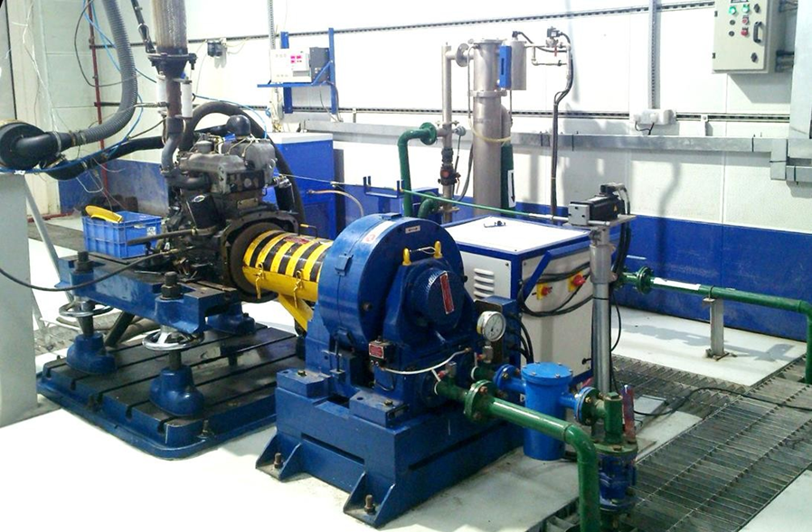

Figure 5.2 Eddy Current Dynamometer

**5.4 AVL Exhaust Gas Analyzer**

Figure (5.3) shows how an AVL gas analyzer (AVL DIX 650) measures emission parameters such smoke opacity, CO, NOx, CO2, and UHC. The one end of this system is connected to the gas analyzer, while the other end is connected to the exhaust gas pipe. The gas analyser’s technical specifications are provided in table.

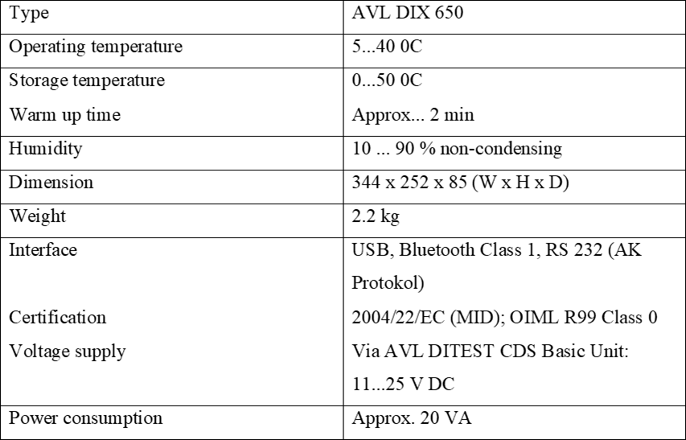

Table 5.2 The specifications of AVL exhaust gas analyzer

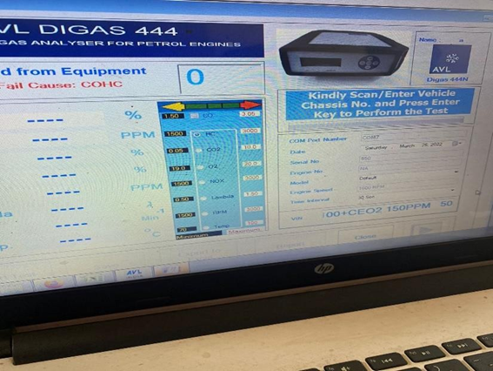

Figure 5.3: AVL Exhaust Gas Analyzer

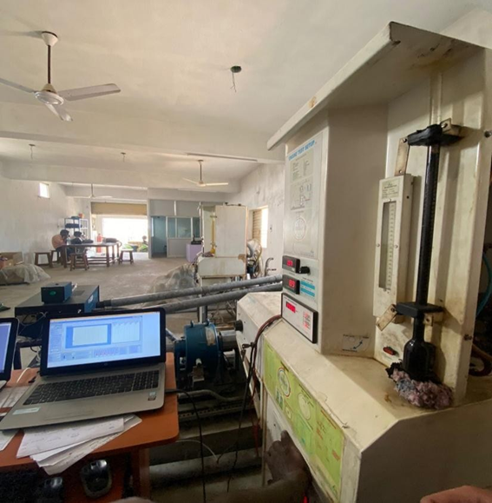

Figure 5.4: CRDI VCR Engine

**5.5 Experimental Procedure**

Initially, the engine was powered by diesel, but it is now powered by CNSL, CNSL+Al2O3 and CNSl+CeO2

**The following steps are used for the experiment:**

* At first, diesel have become filled in fuel line tank of CRDI VCR engine adjusted with a compression ratio 18:1.
* Then the water is provided through the motor. The calorimeter and cooling water go with the flow have become set 75LPH and 150LPH (litre in the line with hour) respectively
* Confirmed an appropriate facility for the piezo cooling sensor and eddy current dynamometer.
* After that, strictly checked all the electric powered factor and connection provided power to the system
* Then diesel became allowed into the engine with the aid of using establishing the knob of the burette.
* The gravity and the calorific cost are adjusted via the configure choice gift with inside the software program for the experiment. vii. The engine became adjusted with injection strain at six hundred bar and injection perspective at 230CATDC with the aid of using configuring choice withinside the software program.
* At 0 load circumstance, the engine became operated for 10 mins with the aid of using choosing the run choice at the software program.
* Pressed the log-on choice proven withinside the software program and permit the diesel supply. The show modified into enter mode and after 1 minute. Thereafter the water flow became entered in calorimeter cooling jackets. Noted the primary analyzing at 0 load circumstance and cost stored withinside the software program with the aid of using creating a file.
* After that became the gas knob to the preceding position. xi. The identical steps had been repeated for distinct load i.e., 3kg, 6kg, 9kg, and 12kg. Their corresponding values had been stored withinside the software program.
* These above-cited strategies had been repeated for a one-of-a-kind mixture of Linseed biodiesel i.e., CNSL And CNSL+CEO2 through converting the gasoline withinside the tank and additionally the corresponding fee of the gravity and CV had been adjusted therefore in the software.
* All those steps observed once more through making use of EGR (14%) this time and values had been Recorded.
* After saving all the values similar to one-of-a-kind mixture at one-of-a-kind masses, furnished 0 masses the engine and after that flip off the device and engine.
* After some minutes, the water deliver changed into stopped too.

**The following precautions are taken during the experiment:**

* All the joints' elements like nut and bolt have been checked strictly and it need to be tight earlier than running the engine.
* The availability of gas withinside the gas line and the gas tank ought to be sufficient.
* Proper cleansing of the flue line and gas tank to do away with the impurities.
* The motor for the water delivers became on earlier than beginning the device for cooling.
* Sensor and touchy device surpassed carefully.

**The following steps were taken for evaluation of emission parameters:**

* When the engine became set on a selected load for a selected mixture then placed the fuel line analyzer sensor within the exhaust pipe of the engine.
* The exhaust gases exceeded thru sensors and readings had been displayed on the virtual screen.
* When the information is stabilized, three next values had been taken and their Mean price became stated for evaluation purposes.
* The exhaust pipe then eliminated from the sensor.
* These steps had been repeated for distinctive blends at distinctive load conditions.
* Their corresponding readings had been stated accordingly.

**CHAPTER 6**

**RESULTS & DISCUSSIONS**

**Combustion parameters:**

Gas Specification (Kilojoules / kg): 1.00, Air Density (kg / m3): 1.17, Adiabatic Index: 1.41, Multi-Feed Index: 1.10, Cycle Count: 10, Cylinder Pressure Reference: 6, Smoothing 2, TDC

**Performance Parameters:**

Orifice Diameter (mm): 20.00, Orifice Coeff. Of Discharge: 0.60, Dynamometer Arm Length (mm): 185, Fuel Pipe die (mm): 12.40, Ambient Temp. (Deg C): 27, Pulses Per revolution: 360, Fuel Type: Diesel, Fuel Density (Kg/m^3): 890, Calorific Value of Fuel (kg. /kg): 37223

**6.1 Performance & Combustion**

**Diesel Characteristics:**

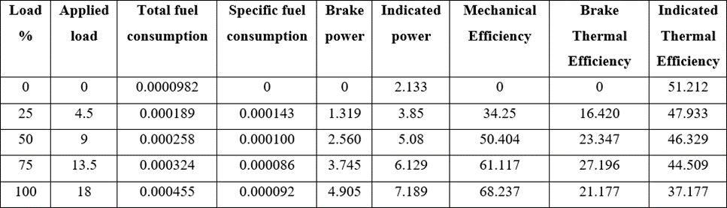

Table 6.1 Performance & Combustion Characteristics of Diesel

**CNSL:**

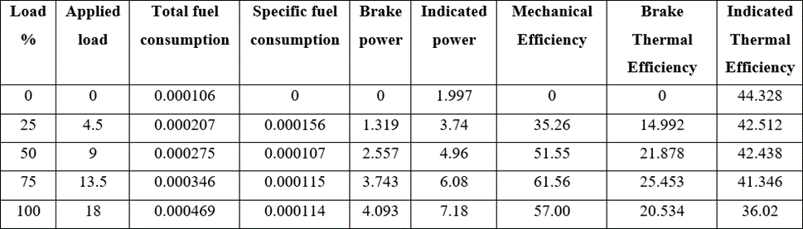

Table 6.2 Performance & Combustion Characteristics of CNSL

**CNSL + Al2O3(100ppm):**

*TABLE IMAGE SHOULD BE ADDED (Excel)*

Table 6.3 Performance & Combustion Characteristics of CNSL + Al2O3(100ppm)

**CNSL + Al2O3(150ppm):**

*TABLE IMAGE SHOULD BE ADDED (Excel)*

Table 6.4 Performance & Combustion Characteristics of CNSL + Al2O3(150ppm)

**CNSL + CeO3(100ppm):**

*TABLE IMAGE SHOULD BE ADDED (Excel)*

Table 6.5 Performance & Combustion Characteristics of CNSL + CeO3(100ppm)

**CNSL + CeO3(150ppm):**

*TABLE IMAGE SHOULD BE ADDED (Excel)*

Table 6.6 Performance & Combustion Characteristics of CNSL + CeO3(150ppm)

Brake Power vs Brake Thermal Efficiency

*GRAPH’S IMAGE’S SHOULD BE ADDED*

**6.2** **Emission Characteristics**

**Diesel:**

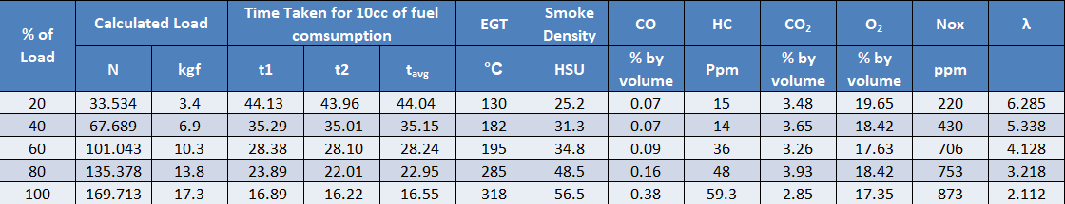

Table 6.7 Emission Characteristics of Diesel

**CNSL 100%:**

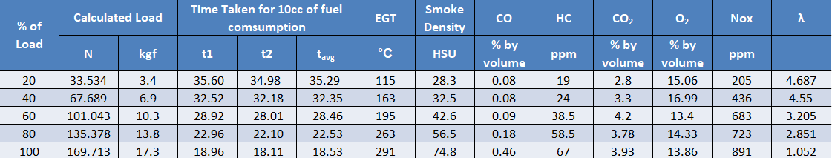

Table 6.8 Emission Characteristics of CNSL 100%

**CNSL + Al2O3 (100ppm):**

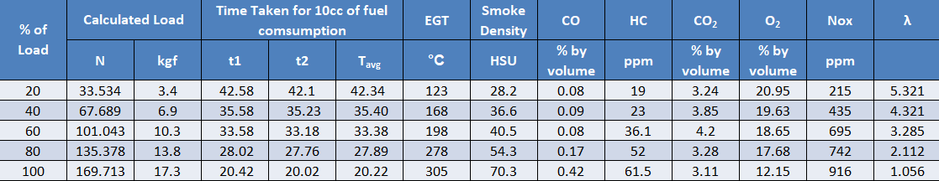

Table 6.9 Emission Characteristics of CNSL + Al2O3 (100ppm)

**CNSL + Al2O3 (150ppm):**

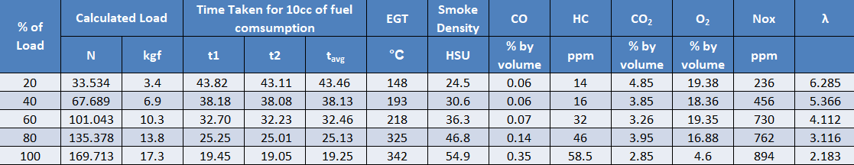

Table 6.10 Emission Characteristics of CNSL + Al2O3 (150ppm)

**CNSL + CeO3 (100ppm):**

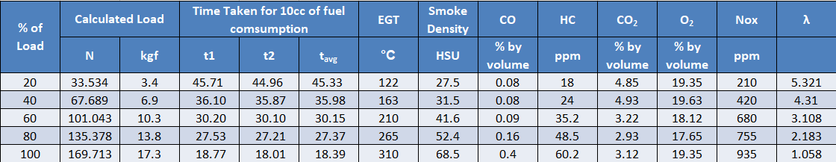

Table 6.11 Emission Characteristics of CNSL + CeO3 (100ppm)

**CNSL + CeO3 (150ppm):**

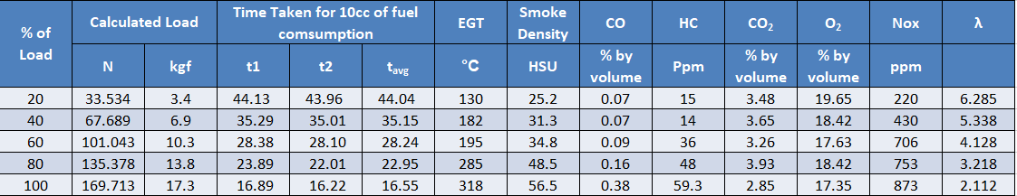

Table 6.12 Emission Characteristics of CNSL + CeO3 (150ppm)

**CHAPTER 7**

**CONCLUSION**

The performance and emission characteristics of a compression ignition diesel engine using a mixture of diesel, TC CNSL and TC CNSL + Al2O3 have been experimentally tested and the following results have been obtained.

* Diesel IP is 6.2% higher than TC CNSL and TC CNSL + CeO2.
* TFC of TC CNSL is 3% higher and TC CNSL + CeO2 7.7% higher than diesel under full load conditions.
* S SFC of TC CNSL is 19.3% higher and TC CNSL + CeO2 is 8% higher than diesel under full load conditions.
* TC CNSL's brake thermal efficiency is 3% lower and TC CNSL + CeO2 is 62% higher than diesel under full load conditions.
* CO CO2 emissions in TC CNSL are 53% higher and in TC CNSL + CeO2 72% higher than diesel under full load conditions.
* CO2 emissions are similar to diesel and TC CNSL, but TC CNSL + CeO2 contains 4.6% more CO2 emissions than diesel under full load conditions.
* H HC emissions are the same for both diesel and TC CNSL + CeO2, but TC CNSL has 5.7% more HC emissions than diesel under full load conditions.
* N NOx emissions in TC CNSL are 24% lower and in TC CNSL + CeO2 30% lower than diesel under full load conditions.

**Future Scope**

Compared to diesel, the biodiesel blends tested have shown better performance and lower emissions. As a result, the TC CNSL + Al2O3 biodiesel mixture can be used as an alternative fuel in diesel engines with a mole ratio of 100 ppm and 150 ppm of Al2O3.

* The government should implement a simple and cost-effective method for producing biodiesel.
* The blend's long-term stability should be investigated because the mixes developed for this investigation were employed in a short period of time.
* Further technological research and progress on other parameters like as wear and tear analysis, fuel injection timing, and crank angle are required for full combustion of biodiesel in CI engines

**REFERENCE**

1. Gavhane R.S.; Kate A.M.; Soudagar; Wakchaure V.D.; Balgude S; Rizwanul Fattah I.M.; Nik-Ghazali N; Fayez H.; Khan T.M.Y.; Mujtaba M.A.; et al. Influence of Silica Nano-Additives on Performance and Emission Characteristics of Soybean Biodiesel Fueled Diesel Engine. Energies 2021,14, 1489.
2. Ashok Kumar, K. Rajan, M. Rajaram Narayanan, and K. R. Senthil Kumar; et al. Experimental study of diesel engine using cashew nutshell oil (CNSO) with varying injection pressures. AIP Conference Proceedings 2039, 020058 (2018); Doi: 10.1063/1.5079017
3. H. N. Dike, A. Dosunmu, B. Kinigoma and O. Akaranta; Characterization of Chemically Modified Cashew Nut Shell Liquid. Journal of Engineering Research and Reports, 8(4): 1-8, 2019; Article no.JERR.52884, ISSN: 2582-2926
4. Michael G. Bidir, N.K. Millerjothi, Muyiwa S. Adaramola, Ftwi Y. Hagos; The role of nanoparticles on biofuel production and as an additive internary blend fuelled diesel engine: A review, Energy Reports 7 (2021) 3614–3627
5. U. S. Jyothi, G. Jeevan Kumar; Impact of Nano additives on optimized Mahua Bio- diesel Performance, E3S Web of Conferences 184, 01015 (2020)
6. Prabu A. Nanoparticles as additive in biodiesel on the working characteristics of a DI diesel engine. Ain Shams Eng J (2017)
7. G. Kasiraman, V. Edwin Geo b, B. Nagalingam et al. / Energy 101 (2016) 402e410, doi: 10.1016/j.energy.2016.01.086
8. S. Vedharaj, R. Vallinayagam, W.M. Yang, C.G. Saravanan, W.L. Roberts et al. / Experimental Thermal and Fluid Science 70 (2016) 316–324
9. M. Sawadogo, S. Tchini Tanoh, S. Sidibé, N. Kpai, I. Tankoano, Cleaner production in Burkina Faso: Case study of fuel briquettes made from cashew industry waste, Journal of Cleaner Production (2018), doi: 10.1016/j.jclepro.2018.05.261
10. S.K. Sanjeeva, Mitchell Preetham Pinto, Manoj Mulakkapurath Narayanan, Gopalakrishna Mangalore Kini, Chandrasekhar Bhaskaran Nair, P.V. SubbaRao, Phani Kumar Pullela, Siva Ramamoorthy , Colin J. Barrow et al. / Renewable Energy 71 (2014) 81e88, doi: 10.1016/j.renene.2014.05.024
11. Senthil Kumar M, Ramesh A, Nagalingam B. Use of Hydrogen to enhance the performance of a vegetable oil fuelled compression ignition engine. J Hydrogen Energy 2003;28(10):1143e54.
12. Campos Fernandez Javier, Arnal Juan M, Jose Gomez M, Dorado Pilar. A comparison of performance of higher alcohols/diesel fuel blends in a diesel engine. Appl Energy 2012;95:267e75.
13. Holman JP. Experimental techniques for engineers. 7th ed. New Delhi: Tata McGraw Hill; 2004.
14. Hazar Hanbey, Aydin Huseyin. Effect of ethanol blending with biodiesel on engine performance and exhaust emissions in a CI engine. Appl Therm Eng 2010;30:1199e204.
15. Soudagar, M.E.M.; Banapurmath, N.; Afzal, A.; Hossain, N.; Abbas, M.M.; Haniffa, M.A.C.M.; Naik, B.; Ahmed, W.; Nizamuddin, S.; Mubarak, N. Study of diesel engine characteristics by adding nano-sized zinc oxide and diethyl ether additives in Mahua biodiesel–diesel fuel blend. Sci. Rep. 2020, 10, 1–17.
16. Shahir, S.; Masjuki, H.; Kalam, M.; Imran, A.; Fattah, I.R.; Sanjid, A. Feasibility of diesel–biodiesel–ethanol/bioethanol blend as existing CI engine fuel: An assessment of properties, material compatibility, safety, and combustion. Renew. Sustain. Energy Rev. 2014, 32, 379–395
17. Hoseini, S.; Najafi, G.; Ghobadian, B.; Ebadi, M.; Mamat, R.; Yusaf, T. Performance and emission characteristics of a CI engine using graphene oxide (GO) nano-particles additives in biodiesel-diesel blends. Renew. Energy 2020, 145, 458– 465.
18. Basha, J.S. An Experimental Analysis of a Diesel Engine Using Alumina Nanoparticles Blended DIESEL fuel; 0148-7191; SAE Technical Paper; SAE International: Warrendale, PA, USA, 2014.
19. Sayin, C.; Ilhan, M.; Canakci, M.; Gumus, M. Effect of injection timing on the exhaust emissions of a diesel engine using diesel–methanol blends. Renew. Energy 2009, 34, 1261–1269.
20. Akinhanmi TF, Atasie VN. Chemical composition and physicochemica properties of cashew nut (Anacardium occidentale) oil and cashew nut shell liquid. J Agric Food Environ Sci 2008;2:1–10.